

**CAT 3 REPORT**

SUBJECT-***DATA BASE MANAGEMNET SYSTEM***

# *(BCSE2073)*

TOPIC-

***CASE STUDY ON REDBUS MANAGEMENT SYSTEM***

SUBMITTED BY SUBMITTED TO

SHRISTI YADAV MR.GULSHAN

21SCSE1011202 SHRIVASTAVA

BTECH CSE

SEC 2 SEM 3 2022-2023

CONTENTS-

1. INTRODUCTION
2. OPERATIONS
3. KEY SERVICES PROVIDED
4. UNIQUENESS & MONEY MAKING PROCESS
5. REVENUE STRUCTURE
6. CONCLUSION

***.INTRODUCTION***

RedBus is an online bus ticketing platform developed in India, headquartered in Bangalore but connects bus travellers with a network of over 2500 bus operators. With a massive audience of more than 18 million, they have expanded their roots across India, Malaysia, Indonesia, Singapore, Peru and Colombia.

redBus is India’s largest online bus ticketing platform that has transformed bus travel in the country by bringing ease and convenience to millions of Indians who travel using buses. Founded in 2006, redBus is part of India’s leading online travel company MakeMyTrip Limited.

### *Management Team* Prakash Sangam, CEO Anoop Menon, CTO

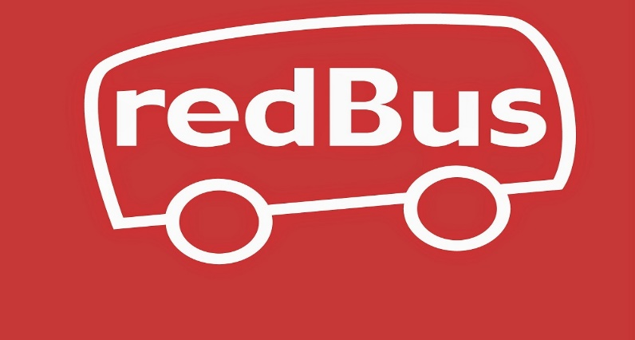

LOGO

### ***.OPERATIONS OF redBUS***

RedBus started with just INR 500000 rupees which was the saving of their 3 co-founders. They had to face several challenges, in the beginning, like, payment gateway issues and propagate the ideal culture, working environment and value system.

To meet these challenges and overcome them, they designed this amazing business model that helped them to reach a 70% share in the Indian online bus ticketing segment.

Redbus is developing a software called BOSS “Bus Operators Software System” used by most travel agents and operators.

The way it works is that the bus operators who use this software use it to manage the seats of their buses in their fleet. They pay an annual premium for the software. All data is stored on AWS on a custom SQL database.

Travel agents have access to an online agent portal or to the software itself.

To provide great benefits and offers for their valuable customers, they are dedicated to providing great customer service. In this way, the company offers the most superior advantage to its customers and that too at a very reasonable.

***.KEY SERVICES PROVIDED***

Now, let’s move to the key services provided to the customers by redBus.

RedBus is the leading bus ticket company that gives an incredible fraction of offerings to its clients, offerings which you can not deny however pick RedBus. And to this result, RedBus has millions of glad and loyal clients throughout the globe.

#### **1 SAFETY+**

With Safety+ they have brought in a set of measures like Sanitized buses, mandatory masks etc. to ensure that their customers travel safely.

#### **2 SUPERIOR CUSTOMER SERVICE**

They put their experience and relationships to good use and are available to solve their travel issues.

#### **3 LOWEST PRICES**

They always try to give their customers the lowest price with the best partner offers.

#### **4 UNMATCHED BENEFITS**

They take care of travel beyond ticketing by providing you with innovative and unique benefits.

redBus has a very classified target audience, to know about them better.

***.TARGET AUDIENCE***

RedBus in particular targets the literate middle-magnificence people throughout the country, who’re really dependable on net services and get to tour a lot.

However, in the beginning, RedBus’s important goal becomes to get as many bus operators as possible. But their concept was rejected by the bus operators due to the fact that they were well in their comfort zone of traditional methods. Then, the founders went for the customer’s pool to drive greater travellers’ site visitors towards their website. This becomes a tremendous achievement and the organization skilled a large boom graph.

It’s the uniqueness only which drives the venture to extreme success. This unique quality in the business model of redBus highlighted them amongst the top players.

### ***.UNIQUENESS***

The quality which separates RedBus from others is that it provides an opportunity to the customers to select their favourable route for their destination. Not only this, RedBus provides its customers with tons of different offers to its customers to get better customer engagements.

Their social media strategies are designed so well that it always finds great proposals for its audiences. Its approach to social media is quite different from others.

In the very next segment, we have the money-making process of redBus.

***.MONEY MAKING PROCESS***

RedBus makes its money from the most effective way of work. It costs a few charges as the fee from the bus operators on every booked ticket on RedBus. The fee comes as 10-20% of the whole ticket value.

The founders commenced the organisation with a quantity of Rs. 500,000 from their savings. When the organisation was built, it did not make any income withinside the first 12 months however in 2009, it acquired a brilliant deal of fulfilment with a turnover really well worth INR 5 crore. Then in 2005, RedBus income grew by 6 times its last.

And now, RedBus has over 18 million users from 24 states, 30,000+ outlets along 80,000 routes, and 2500 bus operators. And known as the largest online bus ticket company.

redBus offers a variety of ticket booking offers.

***.TICKET BOOKING OFFERS***

RedBus definitely makes it more convenient and comfortable for its customers by providing multiple travel Bookings offers such as

* Thousands of routes across multiple travel options.
* Efficient customer service
* Low fare of tickets
* Pilgrimage tours
* Discounts, deals and festival offers, etc
* Mobile ticketing App
* Bus hirings

***REVENUE STRUCTURE***

As we know that their primary revenue model is very simple. redBus charges commission from the bus operator on every ticket booked through their platform. The commission is around 10-20% of the value of the ticket being sold.

But, what we don’t know is that they have another source of income too.

redBus also sells its ticket booking software to bus operators. This software is easy to comprehend and operators can book tickets, manage to book and optimise.

So, even if you buy tickets directly from the operators offline, they will most probably use the software provided by redBus.

Not their business model but also their implementation, has made them one of the biggest acquisitions in the Indian startup scene.

***CONCLUSION***

RedBus has had enormous success since its launch in 2006. There are tons of bus services available 24×7 and meets all the needs of the traveller. Its business model is quite simple and strong but most importantly, RedBus is wildly famous and welcomed among the common people.

As it eases its major issue with finding a fine bus for any destination. It’s one step closer to fulfilling every need of a traveller along with its destination requirements. RedBus was one of its kind and it’s a true inspiration for developing services for the betterment of common people.

So, we also now know that Online Marketing skills are gaining importance in today’s corporate world. As in the case of redBus, digital presence only helped them to come up with a solution and establish a great venture out of that.

THANKYOU